**TUSHAR SOOD**

*Bangalore, KA | +91 98451 97977 |* [*www.tusharsood.com*](http://www.tusharsood.com) *|* [*tushrsood@gmail.com*](mailto:tushrsood@gmail.com)

**Technology and Business Executive**

Product Incubation and Technology Innovation for Competitive Advantage

Senior executive with over 14 years of consistent record, growing revenue, creating winning products and improving operational performance. Distinctive blend of skills encompassing **thought leadership**, technology and operations consulting, product management and building high performance teams.

Areas of expertise:

|  |  |
| --- | --- |
| * **Product Innovation and Development** * Innovative Pre-sales * Vendor Negotiations * Leading geographically distributed teams | * **Solution Sales and Technology Consulting** * Program Management * Cloud Strategy Consulting * Operations and People Management |

**CAREER HIGHLIGHTS**

* **Leadership**: Instrumental in setting up the healthcare product development and delivery practice at HealthFore.
* **Product and Innovation Management**:
  + Established the Product Engineering group in a start-up environment and delivered an enterprise class Hospital Information System (HIS) in under two years.
  + Expertise in identifying and delivering **Minimum Viable Product**, having incubated multiple products over the past decade.
  + Implemented **agile development process** for HealthFore’s flagship product, enabling short time-to- market with excellent understanding of ***ISO and CMMi standards***.
  + Partnered with external vendor’s viz. Microsoft, IBM, Sify, Robert Bosch to extend the product reach.
  + Hands-on experience in IaaS, PaaS and cloud technologies.
* **Pre-sales and Program Management**: Headed the Program Management initiatives for HealthFore including greenfield hospitals in Middle East and Africa region – over $20M portfolio. Earlier, lead the M&A of a complementary product company, defining the integration plans and overall product management strategy.
* **People Management**: Have successfully led team efforts, of both technical resources and SMEs, across geographies with the ability to concurrently manage multiple assignments.
* **Consulting**: Good exposure to go-to-cloud strategy, hardware sizing and Microsoft product licensing.
* **Onsite** and **presales experience** of interfacing with clients and users from USA, Australia and the Middle East.

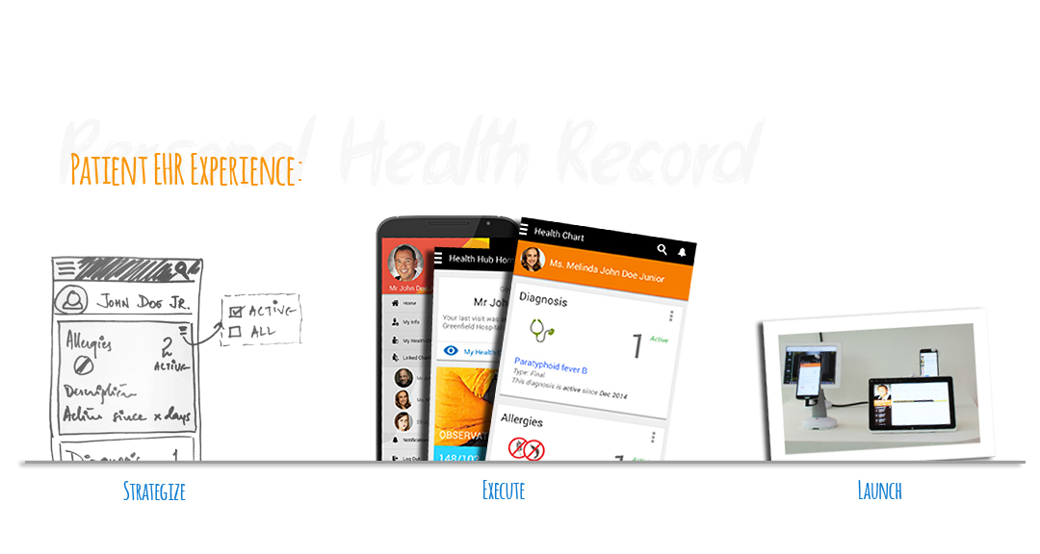

**PROFESSIONAL EXPERIENCE**

***HealthFore Technologies Limited*** *(formerly Religare Technologies Ltd.),* ***Bangalore*** *Apr 2007–Present*

*General Manager*

*HealthFore is a global healthcare products and IT solutions company with products for mid to large sized hospitals, diagnostic centers and public health enterprises.*

**Owned** and **delivered** the organizations’ flagship enterprise class Hospital Information System. The role encompassed multiple responsibilities including **Scrum** lifecycle **implementation, program management, go-to-market strategy, pre-sales,** requirement elicitation and **QMS definition**. Empowered the product suite by implementing open source solutions like CMS portal, product knowledge base and request management tracker, thus resulting in higher CSAT and repeat business.

*Significant accomplishments included:*

* + **Incubated and led the Product Engineering group**. Defined the strategy, roadmap, processes and methodologies, hired and mentored the core team, implemented and deployed the first beta version (at a hospital) in under six months. The product has hence evolved into an enterprise class application and currently **deployed across multiple care facilities in Middle East, Africa** and **India**.
  + Formed HealthFore’s **mobile development** practice, building ancillary products on iOS, Android and Windows Store Apps.
  + Headed the Program Management office to improve the overall client acquisition and product enablement lifecycle.
  + Planned strategic partnerships with development partners and UX firms to complement product offerings, including hosting on third party cloud and Windows Azure.
  + Successfully lead the organization through multiple ISO and CMMi audits.
  + **Key member of the leadership team driving the overall technology roadmap including cloud enablement, Azure strategy, mobile extensions and Hadoop initiatives.**
  + Product Manager and Architect of VDMS, Religare and Fortis’ IP based product for Contract Research Organizations resulting in yearly savings of over INR 10-15Lakhs per center – early adopter for biometric based identification

***Dion Global Solutions*** *(formerly Asian CERC),* ***Bangalore*** *Inter-company transfer*

*Senior Manager*

*Dion Global Solutions is a leading provider of end-to-end trading products for the financial securities market.*

Led the company during a period of rapid growth (>100%). Spearheaded business strategy planning and product roadmap, delivery of multiple new products, account management, partner and vendor management. Imparted product and technology directions, improved efficiency of service delivery, optimized costs and customer support.

*Significant accomplishments included:*

* Setup the company’s Microsoft.Net practice and redesigned the organization’s legacy products for web-based trading and for disseminating financial services data.
  + Key member of Web 2.0 pre-sales team for Religare Technova’s consulting services.
  + Technology evangelism on various technologies viz. Blackberry development, HP Non-Stop, Business Rules Engines, BPM and various CMS tools
  + Received the ***Star award*** for designing and building a Portfolio Management tool, for a leading Wealth Management firm in under 45 days, generating high revenue for the organization

***The Timken Company, Bangalore*** *July 2001– April 2007*

*Systems Analyst*

*The Timken Company, headquartered in Canton, OH, is a worldwide leader in industrial bearings and steel with its R & D center at Electronics City, Bangalore*

Hired as a rookie, grew through the ranks to independently lead onsite requirement gathering, development and implementation of various business critical Supply Chain and HR Systems for the organization.

*Significant accomplishments include:*

* + Growing Responsibility – Successfully lead the HR Systems India development team through development of multiple modules, with special emphasis of scalability and multi-lingual capabilities
  + Played a pivotal role in **transitioning** the HR Systems (Canton, OH) development work to offshore development center in Bangalore, India
  + Conceptualized and implemented, offline Talent Management Process (TMP) review with XML based data sync, a first for the organization
  + Architected and implemented the global TMP product suite for Timken employees across 25 countries, supporting 11 languages
  + Architected and implemented Price Deviation Request app, helping surge deal closure by 17% during the first six months
  + Successfully **partnered** with Hyland Software’s OnBase DMS for automating the Corporate Shared Services’ processes
  + Designed and developed over 20 applications for supply chain and HR systems, by independently collecting onsite requirements, designing, coding and implementing across various business teams
  + Received the organizations’ first ever ***Above and Beyond Call* *award*** for designing and coding the TMP .Net suite under stringent timelines to conduct yearly appraisals for over 18,000 employees.

**EDUCATION**

Masters in Computer Applications, Christ College, Bangalore University 1998-2001

**RECOMMENDATIONS**

<https://www.linkedin.com/in/tusharsood>